GGN - Geopark Annual Report 2018

1. GEOPARK IDENTITY
Geopark name, country, regional Network: Sanqingshan UNESCO Global Geopark (China, Asia-Pacific Geoparks Network)
Year of inscription / Year of the last revalidation: 2012/2018
Representative Photo (from the most important event this year)
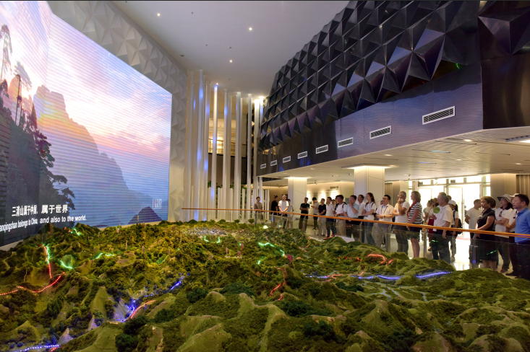
Experts of the Revalidation Mission visiting Sanqingshan Museum for the Area Extension of Sanqingshan UNESCO Global Geopark

2. GEOPARK FIGURES
Number of Geopark staffs: 325 staffs including 4 geologists
Number of Visitors: 1863300
Number of Geopark events: 23
Number school classes realize Geopark educational programmes: 26
Number of Geopark press release: One article was accepted by the Office of Global Geopark Network, and over 80 pieces of news were released on news media; and over 230 posts were delivered to and released on the WeChat Public Platform

3. GEOPARK ACTIVITIES
Major achievements in 2018
From July 10-13, 2018, UNESCO expert Hartmut Escher (Germany), Catharina Posthums (Netherlands) made a field revalidation mission to Sanqingshan Global Geopark. The expert team gave full recognition to the efforts Sanqingshan has made in geopark construction and management, protection of geological relics, socio-economic development, and geo-education and science popularization.

Contribution towards GGN - Networking and Participation
Sanqingshan Global Geopark dispatched its representatives to participate the 8th International Conference on UNESCO Global Geoparks and the 4th UNESCO GGN International Training Course, 2018 Annual Meeting on China’s UNESCO Global Geoparks, and the special seminar on the revalidation of UNESCO Global Geoparks, and others related to geoparks management. Sister park agreements were concluded with Tianzhushan Global Geopark and others. Representatives from Tianzhushan and other global geoparks were invited to visit Sanqingshan. Field visits were made to the North Pennines AONB Geopark of the United Kingdom, Adamello Brenta Geopark of Italy, and Yandanshan and Taishan Global Geoparks of China.

Management and Financial status
Sanqingshan Geopark Administration Committee is in full charge of the overall planning, conservation, operation and construction of the Geopark. The Administration Committee has set up complete management institutions with full functions and sound operation. The Geopark’s revenue comes mainly from the admission tickets, taxation and special appropriation of the high-level government authorities. Presently, the Geopark has a good balance of income and expenditures and the overall financial status is sound and stable.

Geoconservation
We have applied Sanqingshan Smart Tourism System to monitor the important sites in the Geopark, and to defend the boundary of these important geo-sites and the surrounding areas. Rangers of the Geopark have conducted daily patrol on the geo-sites and resources periodically based on their duty posts by adopting a grid management model. Activities for geo-education and science popularization were regularly carried out to raise the conservation awareness of the general public toward the geo-sites.

Sustainable tourism (Geotourism)
The internal exhibition in the Sanqingshan geological museum was rearranged. The Peripateticism Canyon Scenic Area for China’s Taoist Culture in Sanqingshan was developed, the Eighteen Dragon Pool Plank Trail was constructed in the Huaiyu Mountain and the aerial path and the gazebos in the main scenic area of Sanqingshan were renovated. Residents of Yukeng Village carried out folklore activities; Ethnic She cultural activities were organized by the She ethnic people in the She village of Yinjiang; Folklore activities of Horse-lantern Drama performances and Gan (Jiangxi) Opera performances in Huaiyu Town were presented. A provincial rural tourism pilot site was created in Baqi village to extend and promote the sustainable rural tourism strategies and tour routes.

New Education programmes on geoconservation, sustainable development and disaster risk reduction
The Geopark carried out serial activities for geoscience education and popularization month on the April 22 Earth Day. This encompassed a diverse range of geoscience education and popularization activities, including giving lectures for geoscience education and popularization of Sanqingshan in which experiments for and interactions with students of the Sanqingshan schools were used to teach students the geoscience and knowledge of Sanqingshan; Disseminating science popularization brochures and posters to tourists; Signature campaigning for “Protecting the Earth, we must start from our behavior”; “Sanqingshan: Stunning Beauty” – A science tour to China University of Geoscience (Beijing), and so on. We also joined the international geoscience education project “I AM A GEOPARKER” designed and hosted by Villuercas Ibores Jara UNESCO Global Geopark of Spain, in which we organized students to shot videos for geoscience education and publicity. We communicated and collaborated with schools in the adjacent areas of the Geopark to extend the coverage of study tours for high and elementary schools. The environmental activities for public welfare were conducted with the title: “For green Sanqingshan, we are taking actions”.

Strategic Partnership
Yushan County, one of our strategic partners, has actively assisted the revalidation mission for the Geopark area extension. We have established cooperative relationships with the hostels adjacent to the Geopark and restaurants and hotels in the Geopark to jointly promote tourism development. Research collaboration was progressing well with Chinese Academy of Geological Sciences, China University of Geoscience (Beijing), Sun Yat-sen University, China Land Press, Geological Survey of Jiangxi Province, Shangrao Normal University, and so on.

Promotional activities
Promotional activities were held in 15 Chinese cities, including Tianjin, Yinchuan, Xiamen and so on. Advertisements of Sanqingshan Imaging were posted at the Tian’anmen Subway Station in Beijing and at the high-speed train stations of nine cities, including Hongqiao of Shanghai, Nanchang, Jingdezhen, Jiujiang, etc.. We held a range of publicity and promotional activities, including the 3rd Ultra Trail Sanqingshan (UTM3Q), the 2nd Internet + Culture and Tourism Innovation Forum, the 1st Innovative Tik Tok Challenge, the COSPLAY party of Cosers and Cos fans, the 1st Yoga Culture Festival of Sanqingshan, the 4th Sanqingshan Cup National Bridge Cards Open Contest and others. We participated the 2nd the Earth’s Most Beautiful Marks Geopark Photo Shooting Contest, and our grand-view photos won the first and second awards; We also participated in the HanaTour International Travel Show 2018, the 1st Beautiful Shangrao Rural Tourism and Culture Festival, and so on.

4. Contacts:
Manager: Wu Hua sqsdzgy@163.com
Scientific Responsible (Geologist): Yin Guosheng sqsdzgy@163.com

